**PXL-Digital**

Bachelor in de elektronica - ICT

**Writing: Nixie bargraph thermometer**

Vak: Project ontwerpen

Docent: Caers Eric

Moeskops Ralph

1. Content

I. Content 1

II. Product Description 2

III. How to Build 3

IV. Encountered Difficulties 4

V. Bill of Materials 5

VI. Bibliography 5

1. Product Description

The product will become a thermometer. You can read the temperature on a nixie tube. Depending on the temperature, it will heat up and give off an orange glow. A temperature sensor will collect data and transmit it to the Arduino. This data is viewed and analyzed by the Arduino Nano. Next the Arduino will calculate what voltage must be applied to the nixie tube. As the voltage increases, the orange glow will rise.

A number of LEDs will also be connected, these serve purely for decoration. Once the PCB is made, you can look at the casing of this thermometer. The case has to be made with a 3D-printer. To make sure the color of the RGB LEDs is visible on the outside, we will be making holes in the lateral aspects of the case. The LED’s will give a nice effect on the outside of the housing.

1. How to Build

The nixie thermometer will be made with a Russian IN-9. This is an illuminated column where the temperature can be read analogously. The thermometer will not be very precise and will be more an indication of the temperature. The nixie tube and the RGB LEDs will be giving the thermometer a high-tech look. Ideal to set on your desk as decoration.

1. Order components

The first step that needs to taken is deciding which components to take in SMD. Without this decision it is not possible to proceed. In this project, we decided to take two ICs and some resistance in SMD. SMD ICs were chosen because they are cheaper and save a lot of space on the PCB. The choice for SMD resistors is only because they make the PCB smaller.

Once this has been decided, all components can be ordered. In this project, everything was ordered via Mauser except for a few components. This for the sole reason that it was not available through Mauser.

The nixie tube was ordered in Russia and the coil has been ordered by RS-online.

1. Draw schema and PCB in Altium

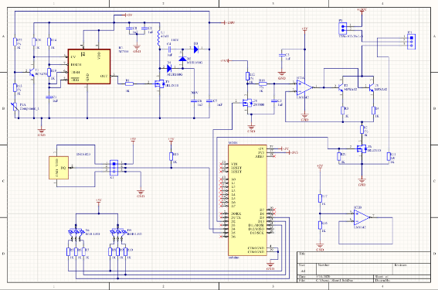Now that all components have been ordered, we can start with the schedule. The scheme is drawn in Altium. The schedule from this project must be transferred from Elektor. No adjustments were needed.

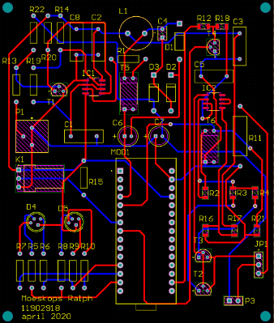Once the scheme has been completely drawn, designing the PCB can start. This is also done with Altium. As soon as the PCB is ready, it can be ordered.

1. Solder the parts on the PCB and test it

The next step is to solder and test all parts on the PCB.

We have already chosen to test the PCB before we mount it into the case. In this way we are sure that all components are properly soldered and that everything works. This is to prevent the situation where we would have to take everything out of the case and rebuild it.

1. Design the case

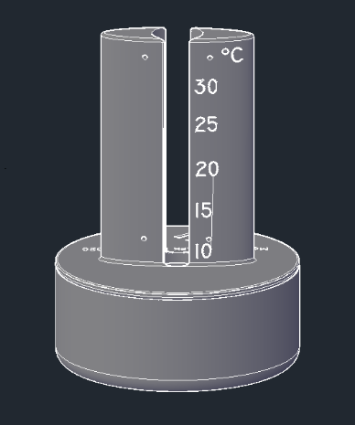Now that the exact dimensions of the electrical part can be measured, the case can be made in Autocad. You should keep in account that the nixie-tube will be hot. Plastic and hot stuff don’t go very good together. So keep a little bit of place between the plastic case and nixie-tube.

1. Finish off

Once the case has been printed with the 3D printer, everything can be mounted. In this project, a high-tech look of the whole case was chosen. The PCB will also be mounted in the case. As a result, it can no longer move separately and it will be more robust.

1. Admire

Lastly, stand back and admire.

1. Encountered Difficulties

During this project I encountered several difficulties. It started with the design of the electrical scheme in Altium. Not all components are on the PCB because they are used externally, as a result there was some confusion.

Another problem I experienced, was when ordering the components. The nixie tube is only made in Russia. Therefore ordering it was not self-evident. After visiting a number of sites that could ship the nixie tube to Belgium, the problem was solved. The tube is made of glass, because it could easily break during transport I bought 1 extra nixie tube while ordering.  
With this design I also had to use a coil to generate 150V. The coil was only available from a company that supplied other companies. This problem was also solved through a detour through my cousin's company.

Furthermore, there were no problems during the design of the PCB. The following issue emerged when designing the case. Something went wrong with the file type because we had to export the PCB from Altium to Autocad. After contact with Kobe Rosius this problem was also solved.

1. Bill of Materials

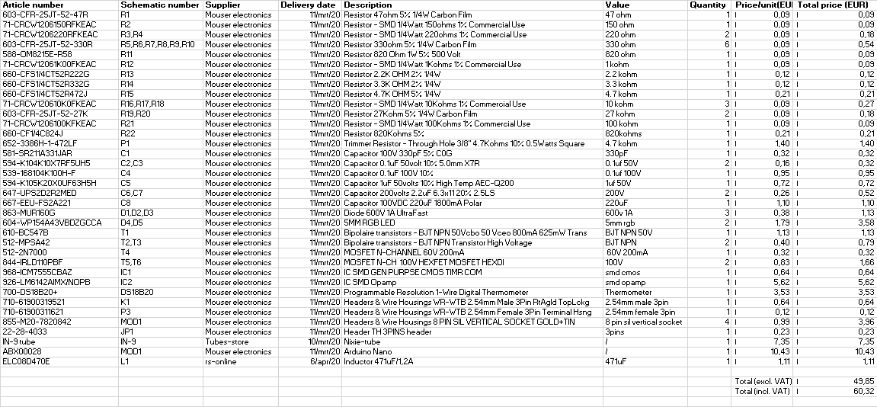

1. Bibliography

|  |  |
| --- | --- |
| [1] | “Nixie Bargraph thermometer,” Elektorstore, August 2018. [Online]. Available: https://www.elektor.nl/nixie-bargraph-thermometer-170589-71. [Accessed 9 March 2020]. |
| [2] | “Mouser,” Mouser electronics, 2007. [Online]. Available: https://www.mouser.be/?gclid=Cj0KCQjwzN71BRCOARIsAF8pjfh9lvnI1RGNqzuPbTMdWhA5MAZnXewR5WBJ3ACwzMT2zaxrjq43-pAaAij5EALw_wcB. [Accessed may 2020]. |